* A PDF detailing:

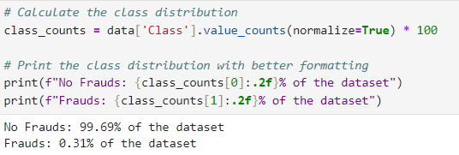

* No Frauds: 99.69% of the dataset
* Frauds: 0.31% of the dataset

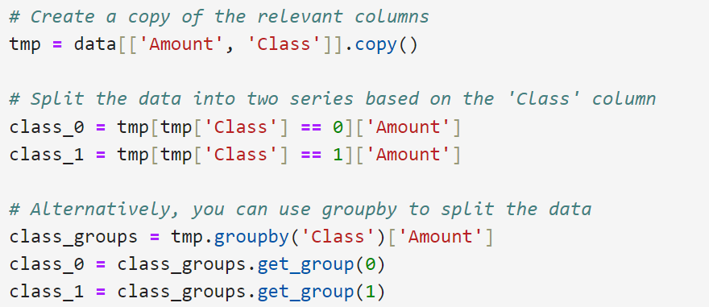

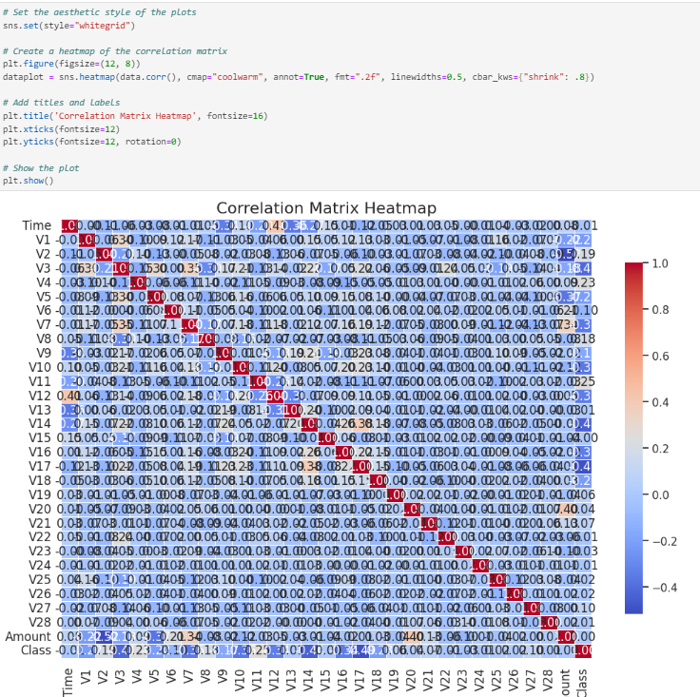

* Logistic Regression (max_iter=1000, random_state=42)
* Accuracy: 0.9873
* Recall: 1.0000
* F1 Score: 0.3273

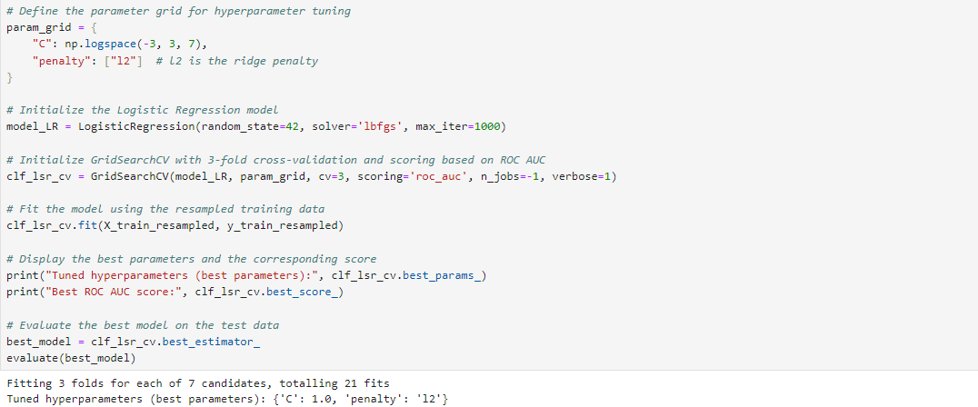

* **Fitting 3 folds for each of 7 candidates, totalling 21 fits**
* **Tuned hyperparameters (best parameters): {'C': 1.0, 'penalty': 'l2'}**

**Best ROC AUC score: 0.9990587160968903**

* LogisticRegression(max_iter=1000, random_state=42)
* Accuracy: 0.9873
* Recall: 1.0000
* F1 Score: 0.3273

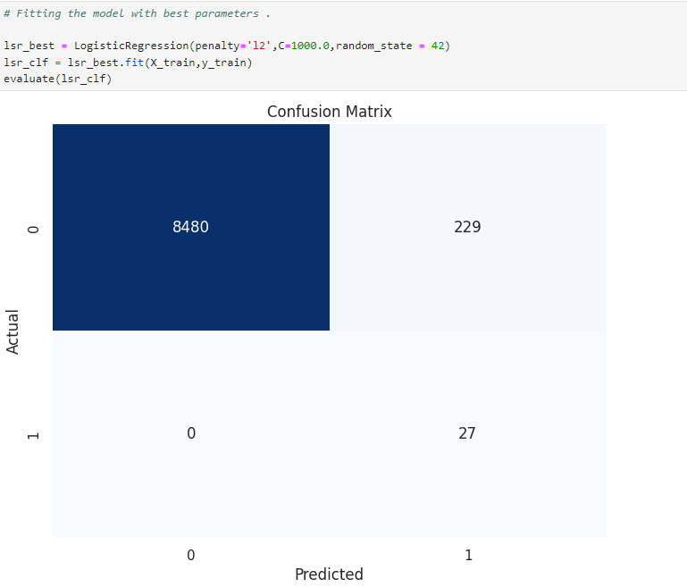

* LogisticRegression(C=1000.0, random_state=42)
* Accuracy: 0.9738
* Recall: 1.0000
* F1 Score: 0.1908

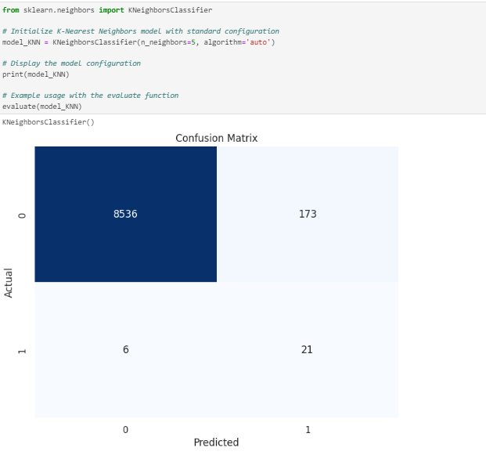

* KNeighborsClassifier()
* Accuracy: 0.9795
* Recall: 0.7778
* F1 Score: 0.1900

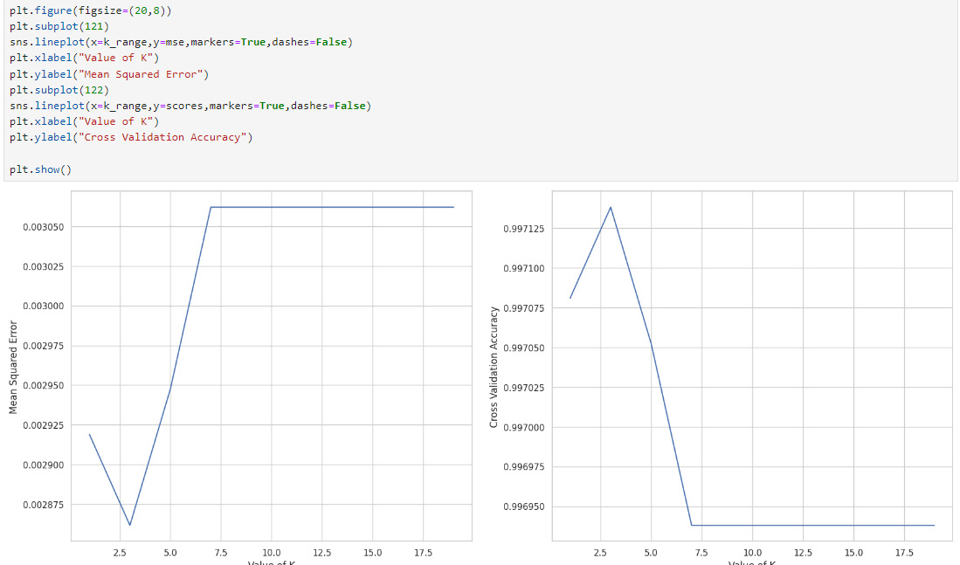

* KNeighborsClassifier(n_neighbors=3)
* Accuracy: 0.9839
* Recall: 0.7407
* F1 Score: 0.2210

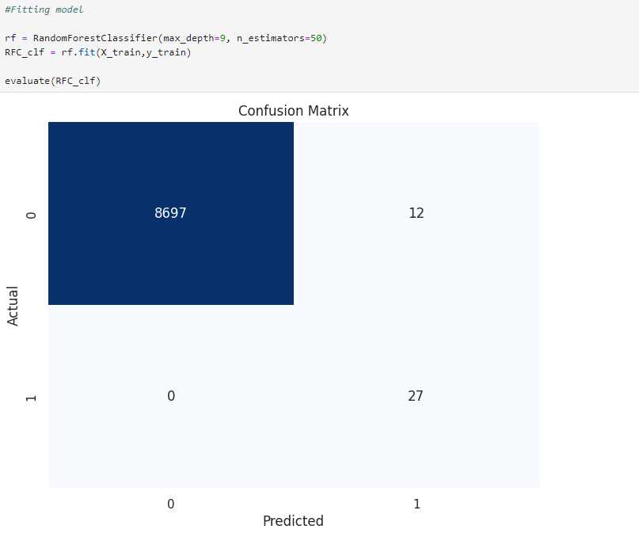

* RandomForestClassifier(max_depth=9, n_estimators=50)
* Accuracy: 0.9986
* Recall: 1.0000
* F1 Score: 0.8182

Model: "sequential"

_________________________________________________________________

Layer (type) Output Shape Param #

=================================================================

dense (Dense) (None, 32) 992

dense_1 (Dense) (None, 16) 528

dense_2 (Dense) (None, 8) 136

dense_3 (Dense) (None, 1) 9

=================================================================

Total params: 1665 (6.50 KB)

Trainable params: 1665 (6.50 KB)

Non-trainable params: 0 (0.00 Byte)



